SEO AUDIT & STRATEGY REPORT
ajmermachine.com
Data source: Google Search Console — Last 3 months (Apr 27 – Jul 26, 2026)
Prepared: July 29, 2026

Is report mein 3 months ka Search Console data analyze karke ek in-depth SEO audit, keyword opportunity mapping, ek critical security flag, on-page (title/description) audit framework, competitor benchmarking approach, aur ek practical 30-60-90 din ka action plan diya gaya hai.

1. Executive Summary
36  Total Clicks (3 mo) | 1,244  Total Impressions | 2.89%  Overall CTR

Sabse bada finding:
Aapke 36 clicks mein se 33 clicks (91%) sirf brand keywords se aa rahe hain ("ajmer machine tools" jaisa). Non-brand product keywords par — jahan 999 impressions hain — sirf 3 clicks aaye hain. Matlab: log aapki company ka naam jaante hain to search karte hain, lekin jab woh "granite polishing machine" ya "derrick crane" jaisa generic product search karte hain, wahan aap unhe nazar hi nahi aate ya bahut neeche rank karte hain.

- Non-Brand CTR sirf 0.3% hai — industry-safe benchmark 3-5%+ hota hai. Yeh on-page (title/description) aur ranking position dono ka problem hai.
- 252 unique search queries mein se 39 queries (~89 impressions, 7.2%) completely unrelated foreign-language / spam terms hain (Japanese swimwear brand, anime terms, random alphanumeric strings) — yeh red flag hai, security check zaroori hai (Section 3).
- Keyword clusters jaise Polishing Machines (234 impressions), Granite Machinery (210), Derrick Crane (203), Cutting Machines (186) mein aap search results mein dikh rahe hain lekin click nahi mil raha — yeh sabse bada low-hanging-fruit opportunity hai.

2. Search Console Data — Deep Dive

2.1 Brand vs Non-Brand Performance
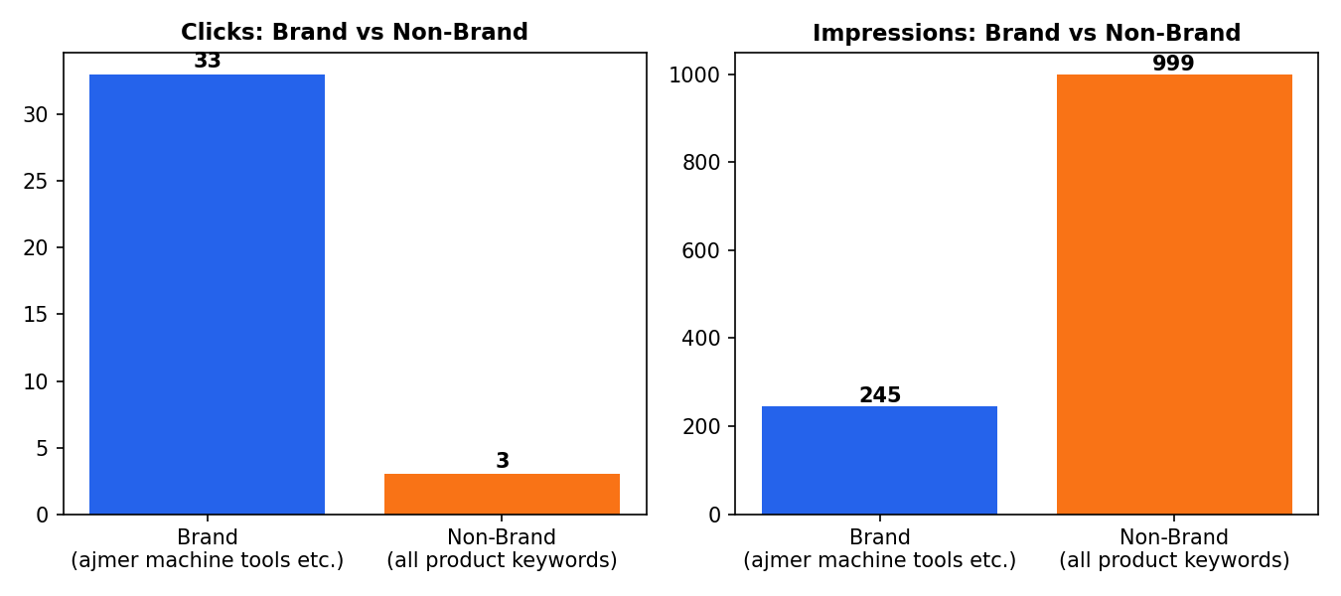
Interpretation: Aapka brand awareness theek hai (13.5% brand CTR — good), lekin product/service discovery bahut weak hai. Iska matlab hai ki jab koi naya customer "aapki company ka naam jaane bina" aapki machine dhundta hai, to Google unhe aapki site dikhata to hai (impressions) par click ke layak nahi samajhta ya title/description compelling nahi hai.

2.2 Keyword Cluster Opportunity Map
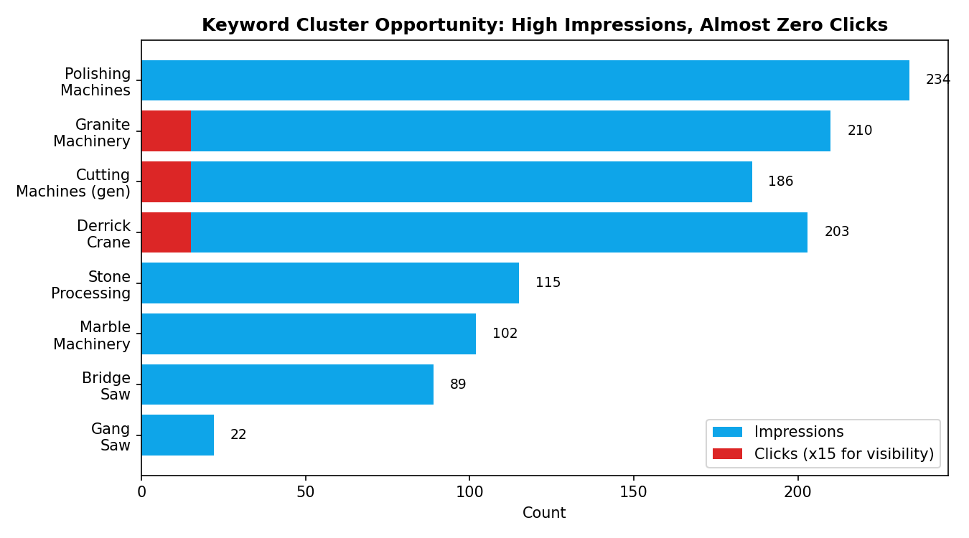
Cluster | # Queries | Clicks | Impressions | Priority
Polishing Machines | 30 | 0 | 234 | HIGH
Granite Machinery | 36 | 1 | 210 | HIGH
Derrick Crane | 32 | 1 | 203 | HIGH
Cutting Machines (general) | 50 | 1 | 186 | MEDIUM
Stone Processing (general) | 28 | 0 | 115 | MEDIUM
Marble Machinery | 26 | 0 | 102 | MEDIUM
Bridge Saw | 19 | 0 | 89 | MEDIUM
Gang Saw | 6 | 0 | 22 | LOW

Note: Cluster ek dusre se thodi overlap karte hain (jaise ek query 'granite cutting machine' Granite aur Cutting dono mein count ho sakti hai) — yeh directional grouping hai, exact deduplication nahi.

2.3 Critical Flag: Spam / Irrelevant Query Anomaly
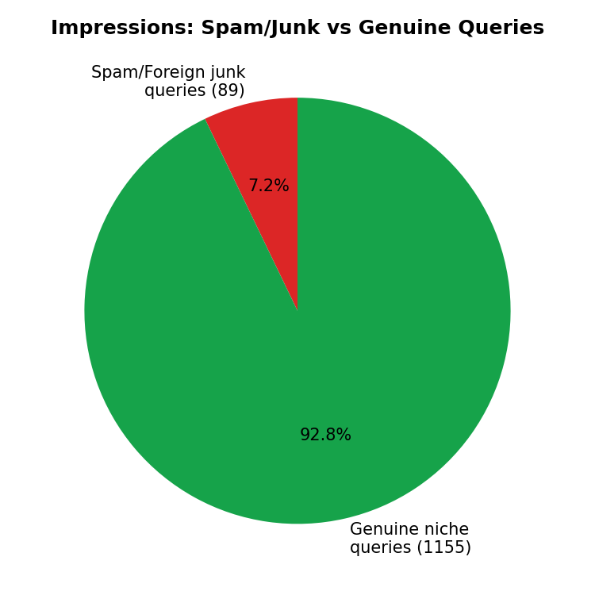
⚠ Security / Technical SEO Alert:
Search Console mein aapki site kuch aise queries ke liye impressions paa rahi hai jinka aapke business (stone/marble machinery) se koi lena-dena nahi — jaise ek foreign swimwear brand ke product-size searches, anime/game terms, aur random alphanumeric strings (jaise "un-10ce8d", "rlxgvj2209cz"). Yeh pattern classically 3 cheezon ka sign hota hai: (1) site par koi spam/hacked pages inject hui hain jo aapko dikhti nahi lekin Google ko dikhti hain, (2) aapki site ka koi purana/expired subdomain ya page abhi bhi index mein hai jahan spam content daala gaya tha, ya (3) third-party negative SEO. Iska CTR par direct impact nahi hai (kyunki click 0 hai), lekin agar yeh spam pages compromise se aaye hain to woh aapki domain authority aur security dono ke liye risk hain.
- Google Search Console > Security & Manual Actions tab check karein — koi manual action ya security issue flag hua hai kya.
- Search Console > Pages report mein dekhein ki kaunse actual URLs in queries ke liye index hain — agar aisa koi URL milta hai jo aapne khud nahi banaya, turant delete/disavow/clean karein.
- Site ka malware scan karayein (Sucuri SiteCheck ya Google Safe Browsing check — dono free hain).
- CMS/plugins/themes ka version update check karein — outdated software hacked-spam-injection ka sabse common reason hota hai.

3. Title & Meta Description Audit
Aapne title/description ka page-by-page audit maanga hai — is report ke data ka source Search Console hai, jismein page-level title/meta text nahi hota (sirf queries aur clicks/impressions milte hain). Live page titles/descriptions dekhne ke liye mujhe live website access (web search/browsing) chahiye, jo abhi is chat mein enabled nahi hai.
Isse jaldi fix karne ke 2 tareeke:
1) Is chat mein 'Web Search' setting ON kar dein — phir main directly ajmermachine.com crawl karke har page ka actual title/description nikaal kar audit kar dunga. 2) Ya aap mujhe apni important pages ke titles/descriptions paste kar dein (Homepage, Products/category pages, Derrick Crane page, Granite/Marble Machine pages, Blog agar hai) — main unhe turant analyze karke rewrite kar dunga.

3.1 On-Page Title/Description Scorecard (Framework)
Jab aap titles bhejenge, main har page ko in criteria par score karunga:
Criteria | Kya check hota hai
Keyword placement | Primary keyword title ke shuru mein hai ya nahi (e.g. 'Granite Polishing Machine Manufacturer' vs generic 'Home')
Length | Title 50-60 characters, Description 140-160 characters (Google truncate na kare)
Uniqueness | Har page ka title/description alag ho — duplicate titles ranking split karte hain
CTR-appeal | Number, USP, ya action word ho (e.g. 'ISO Certified', 'Since 1998', 'Get Quote')
Location signal | Ajmer/Rajasthan/India mention ho agar local+export dono target hain
Brand tag | End mein '| Ajmer Machine' consistent brand suffix

3.2 Example Rewrites (based on your top keyword clusters)
Yeh sirf example templates hain — actual current titles dekhe bina final version nahi de sakta, lekin yeh pattern follow karein:
Page Type | Suggested Title (~60 char) | Suggested Description (~155 char)
Homepage | Ajmer Machine | Stone, Marble & Granite Machinery Manufacturer | ISO-certified manufacturer of granite polishing, bridge saw, gang saw & derrick crane machines in Ajmer, India. Request a quote today.
Derrick Crane page | Derrick Crane Manufacturer in India | Ajmer Machine | Heavy-duty derrick cranes for stone & marble industry, customized capacity. 25+ years experience. Get pricing & specs from Ajmer Machine.
Granite Polishing Machine | Granite Polishing Machine Manufacturer | Ajmer Machine | Automatic & multi-blade granite polishing machines built for high-output slab finishing. Made in India, exported worldwide. Enquire now.
Bridge Saw / Cutting page | Bridge Saw Cutting Machine for Marble & Granite | Ajmer | CNC & manual bridge saw machines for precision marble, granite & quartz cutting. Durable, low-maintenance design. Request a demo.

4. Top 5 Competitor Analysis
Transparency note:
Accurate competitor benchmarking ke liye main live Google results check karta hun — kisi bhi keyword (jaise 'granite polishing machine manufacturer india') ko search karke top ranking sites nikaalta hun aur unke title/content/backlinks compare karta hun. Yeh action is chat mein web search enabled hote hi 2 minute mein ho sakta hai. Abhi ke liye main aapko is section ka structure/framework de raha hun + aap agar 5 competitor names/URLs bata dein (jo aapko pata hain ki wahi log aapke real customers churate hain), to main unhe turant detail mein analyze kar dunga.

4.1 Competitor Analysis Framework (jo main use karunga)
Parameter | Kya compare hoga
Ranking keywords | Woh kaunse keywords par top-10 mein hain jinpe aap nahi hain (keyword gap)
Content depth | Kya unke paas har machine ka dedicated page + spec sheet + video hai
Domain Authority / Backlinks | Kitni aur kaisi websites unhe link kar rahi hain (directories, B2B marketplaces, press)
Blog/resource section | Kya unka blog regularly publish hota hai, kis topic par
On-page SEO | Title/description/schema markup quality
Technical | Page speed, mobile-friendliness, HTTPS, structured data

4.2 Likely Competitive Landscape (general industry knowledge — verify with live search)
Ajmer/Rajasthan stone-machinery niche mein aam taur par competition 2 categories se aata hai — inhe verify karne ke liye web search/aapke inputs chahiye:
- Established Indian manufacturers with strong web presence in stone/marble/granite machinery (multiple listed on IndiaMART/TradeIndia with keyword-rich category pages).
- International brands (Italian/Chinese origin) jinke India distributors hain aur jo 'granite polishing machine', 'bridge saw' jaise generic keywords par global content authority ki wajah se rank karte hain.
- B2B marketplace listings (IndiaMART, TradeIndia, Alibaba) jo khud hi in keywords par rank karte hain aur direct manufacturer sites ko niche dhakel dete hain — yeh aksar sabse bada 'invisible competitor' hota hai.
Agar aap 5 actual competitor URLs de dein, main next message mein unke titles, content structure, aur keyword gaps ka side-by-side comparison table bana dunga.

5. Keyword & Content Strategy — 'Brand ke alawa baaki pages rank karwane ke liye'

5.1 Pillar–Cluster Silo Model
Har product category ke liye ek 'Pillar Page' banayein (broad, comprehensive) + us pillar ko support karne wale 'Cluster/Blog Pages' (specific, long-tail). Internal linking se dono connect karein:
Pillar Page (create/optimize) | Supporting Cluster Blog Ideas
Granite Polishing Machine | 'Automatic vs Manual Granite Polishing Machine', 'How to Choose a Multi-Blade Granite Cutter', 'Granite Polishing Machine Maintenance Guide'
Derrick Crane | 'What is a Derrick Crane? Types & Uses', 'Derrick Crane vs Tower Crane', 'Derrick Crane for Stone Quarry — Buying Guide'
Bridge Saw / Cutting Machine | 'CNC Bridge Saw vs Manual Bridge Saw', 'Bridge Saw for Marble Slab: Complete Guide', 'Top 5 Uses of Bridge Cutting Machine'
Gang Saw Machine | 'Gang Saw vs Multi-Blade Cutter: Which is Better', 'Gang Saw Machine Maintenance Tips'
Marble/Stone Processing (general) | 'Complete Stone Processing Line Setup Guide', 'Stone Machinery Manufacturer in India — What to Check Before Buying'

5.2 Quick-Win Keywords (High impressions, currently 0 clicks — fastest to fix)
Keyword | Impressions | Why it's a quick win
line polishing machine | 46 | Already showing — likely just below page 1 or weak title/meta
granite polishing machine | 35 | High intent buyer keyword, core product
efficient stone processing machine manufacturer | 27 | Long-tail, low competition, high buyer intent
line polish machine | 22 | Duplicate/near-duplicate of above — consolidate content
marble granite processing machines | 21 | Broad category page opportunity
bridge cutting machine | 19 | Dedicated page needed if not present
Strategy: In queries par pehle dedicated, optimized page banayein/behtar karein (ek generic 'Products' page ke bajaye), phir 2-3 weeks track karke position improve hone dekhein.

6. Practical Action Plan (30–60–90 Days)

Next 30 Days — Fix & Foundation
- Security scan + Search Console manual-action check (spam query issue) — Priority #1
- Rewrite title + meta description for Homepage + top 5 product pages (use framework in Section 3)
- Ek dedicated page banayein har major product ke liye agar abhi generic 'products' page hi hai (Granite Polishing, Derrick Crane, Bridge Saw, Gang Saw — alag alag URLs)
- Google Business Profile setup/optimize karein (Ajmer location + service area) — local + B2B searches dono help karega
- Submit updated XML sitemap in Search Console

Next 60 Days — Content & Authority
- 2 blog posts per pillar publish karein (Section 5.1 list se) — total 8-10 blogs
- Har product page mein spec sheet (PDF), video demo, aur customer testimonial add karein — dwell time aur trust dono badhega
- IndiaMART/TradeIndia listings ko website ke sath consistent NAP (Name/Address/Phone) aur backlink ke liye optimize karein
- Schema markup add karein (Product + Organization + LocalBusiness) — rich results ke chances badhte hain
- 5 actual competitors identify karke unke backlink sources check karein (directories, industry associations) — same jagah listing banayein

Next 90 Days — Scale & Monitor
- Har quick-win keyword ka position track karein weekly (Search Console Performance tab)
- Naye blog posts se internal links pillar pages ko dein — silo strengthen karein
- Guest post ya industry directory se 3-5 quality backlinks acquire karein
- Non-brand CTR trend recheck karein — target: 0.3% se 1.5-2%+ tak le jaana
- Spam query issue dobara check karein — agar resolved nahi hua to hosting provider/security expert involve karein

7. Next Steps — Mujhe Yeh Chahiye Poora Audit Complete Karne Ke Liye
Full audit complete karne ke liye:
1) Web Search setting ON karein is chat mein — taaki main live site crawl karke actual titles/descriptions/content nikaal sakun.
2) 5 competitor websites ke naam/URL share karein jo aapko lagta hai real competition dete hain.
3) Agar aapke paas already Google Analytics hai, uska data bhi share karein — bounce rate aur session duration se content quality ka aur pata chalega.
Yeh mil jaane ke baad main ek Part-2 report bana dunga jismein: har page ka actual title/description score, real competitor-vs-you keyword gap table, aur backlink gap analysis hoga.

